FLIGHT MANAGEMENT SYSTEM

PREPARED FOR:

JEE Cloud Training Program Capgemini Technology Services

PREPARED BY:

SowmyaReddy Vangala

**Abstract:**

The Flight Management System is a Java-based booking solution for flight tickets. It consolidates data provided by different airline carriers and hence provides the user details and rates in real-time. Travellers may want to make changes in their bookings. The application allows them to book, cancel, view and update their bookings with ease. Other than this, it eases the management of bookings too. All the bookings, flights, schedules and routes can be viewed, added and modified on a single application by the administrator.

**Class Diagram:**

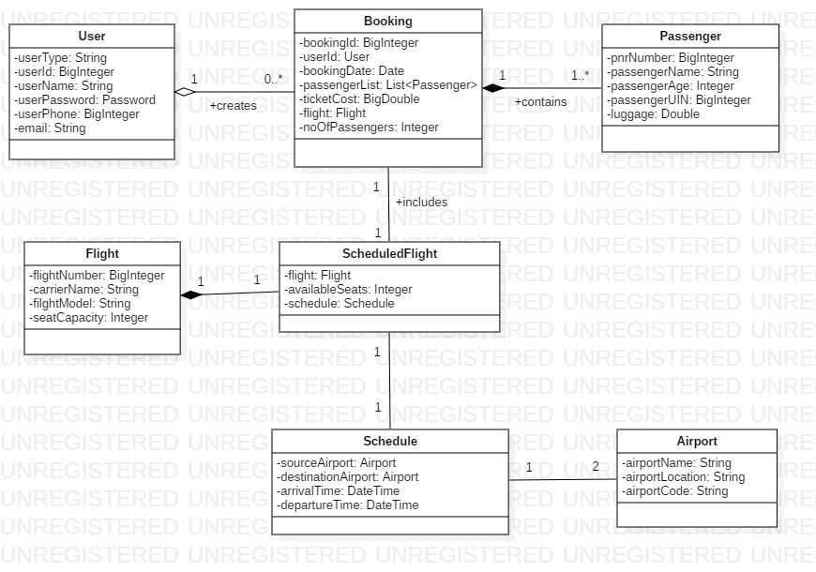

**Sequence Diagram for Admin:**

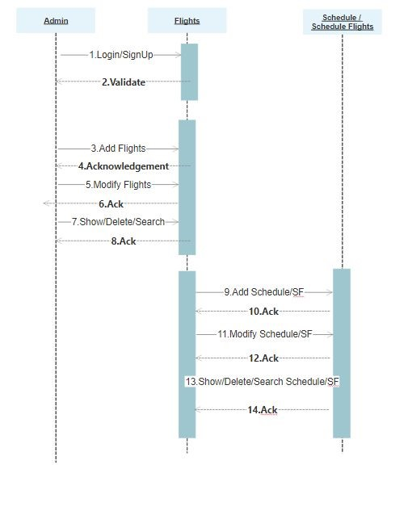

**Activity Diagram for Admin:**

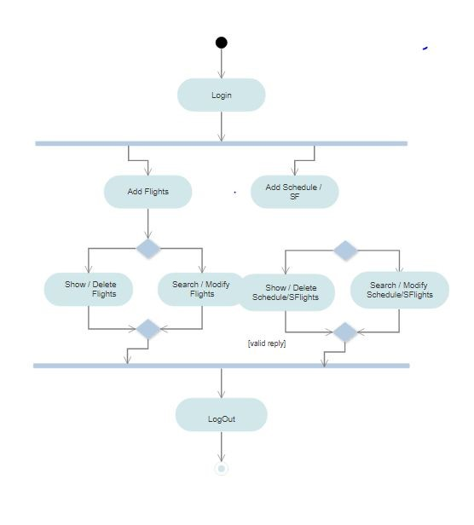

**Requirements:**

Dto layer:

1. **Schedule**:​ This class stores a flight schedule.

Attributes:​

SourceAirport: Airport

DestinationAirport: Airport

ArrivalTime: DateTime

DepartureTime: DateTime

1. **Airport**:​ This class stores the details of an airport.

Attributes:​

AirportName: String

AirportCode: String

AirportLocation: String

Service layer:

**1. AirportServiceImpl:**

Attributes:​ -

Methods :​ viewAirport(): List<Airport> :- Returns the list of all airports.

viewAirport(String): Airport :-

Returns the details of an airport identifiable by the airport code.

Dao layer:

1. **AirportDaoImpl:**

Attributes: airportList: List<Airport>

Methods: viewAirport(): List<Airport> :- Returns the list of all airports.

viewAirport(String): Airport :- Returns the details of an airport identifiable by the airport code.